**List of Certification for AI Assisted Coding**

**Certification#1**

Title: Introduction to Git and GitHub

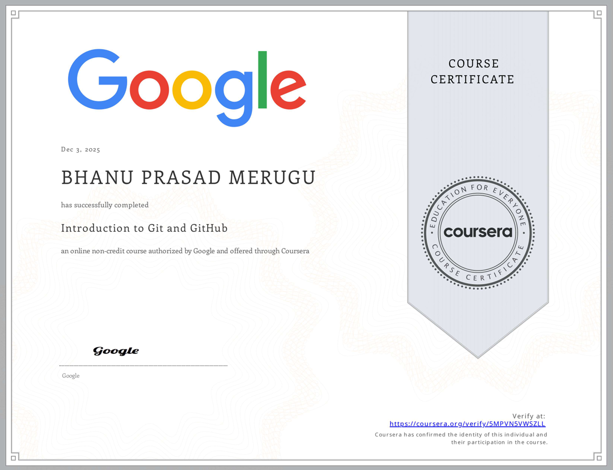

**Certification#2**

Title: Prompt Engineering

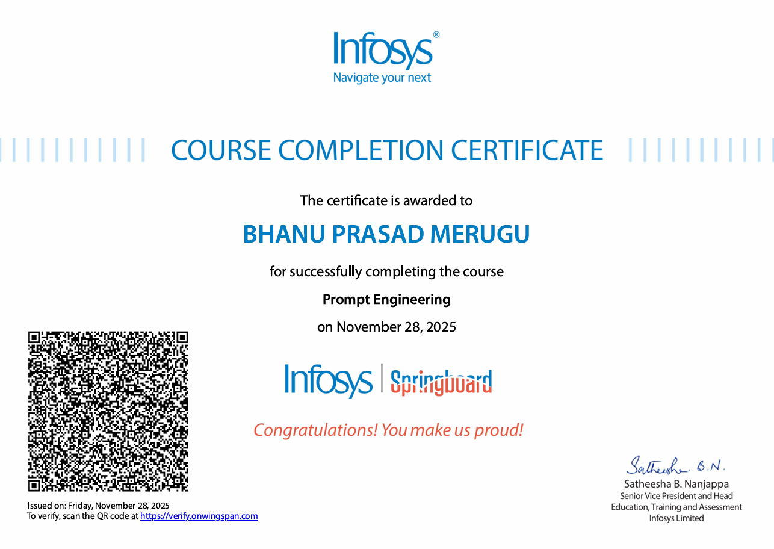

**Certification#3**

Title: GitHub Copilot for developers

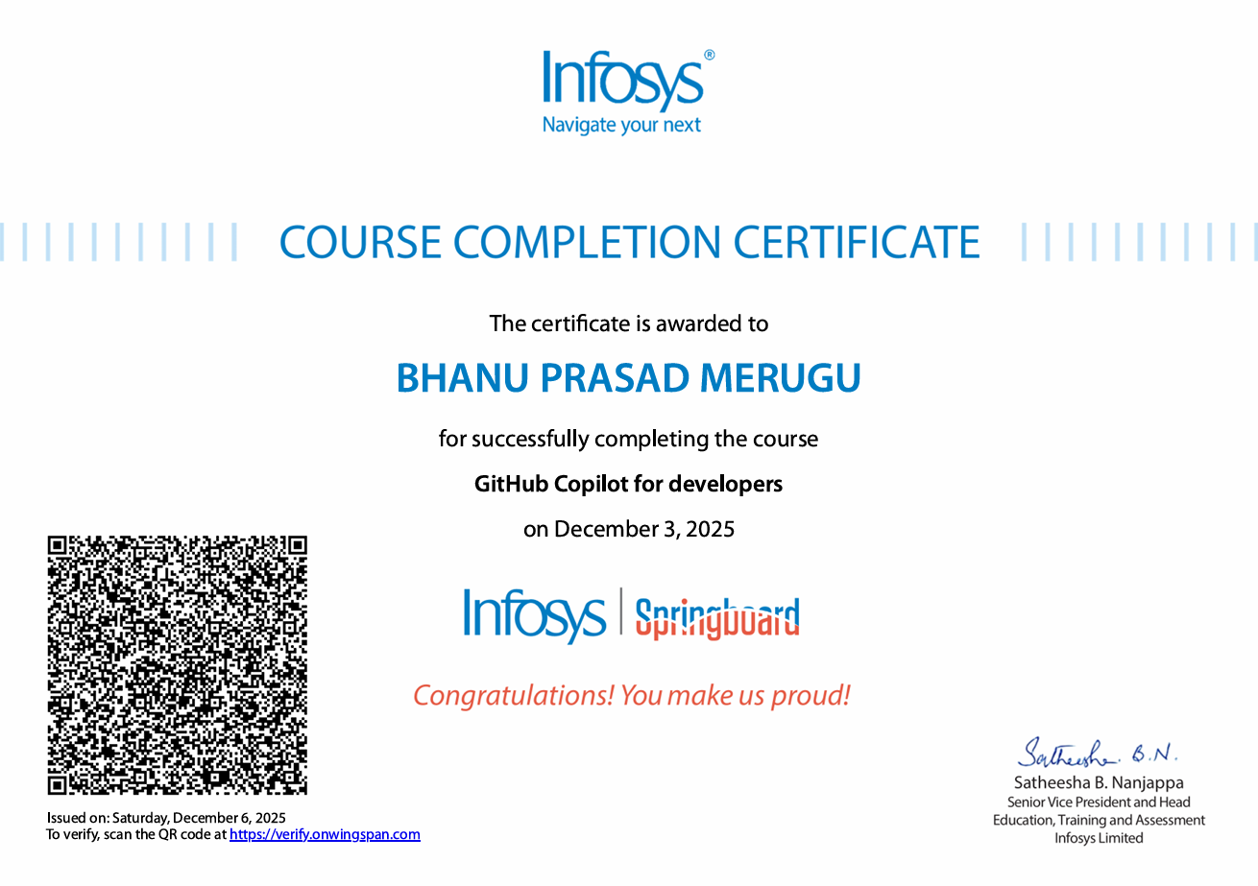

**Certification#4**

Title: Build Generative AI Apps and Solutions with No-Code Tools

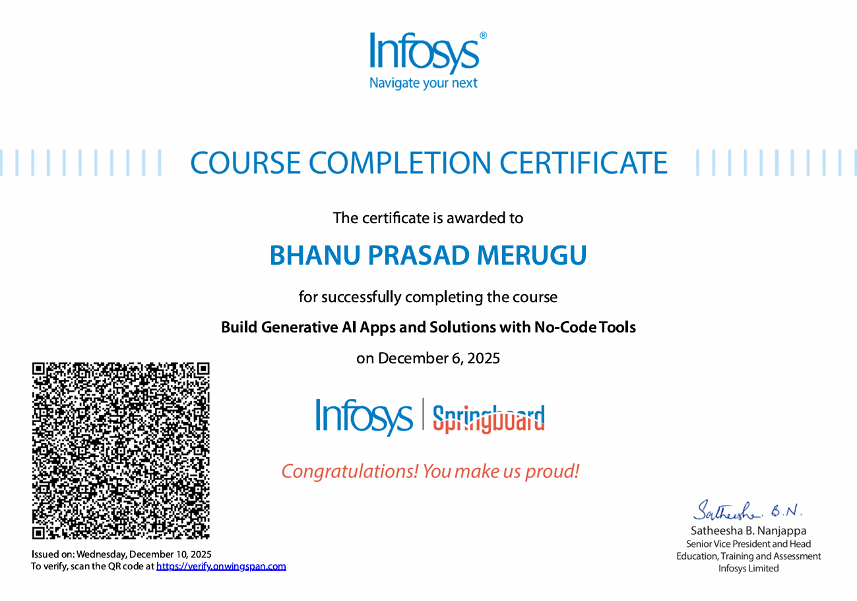

**Certification#5**

Title: GenAI for IT: Transforming IT with Generative AI

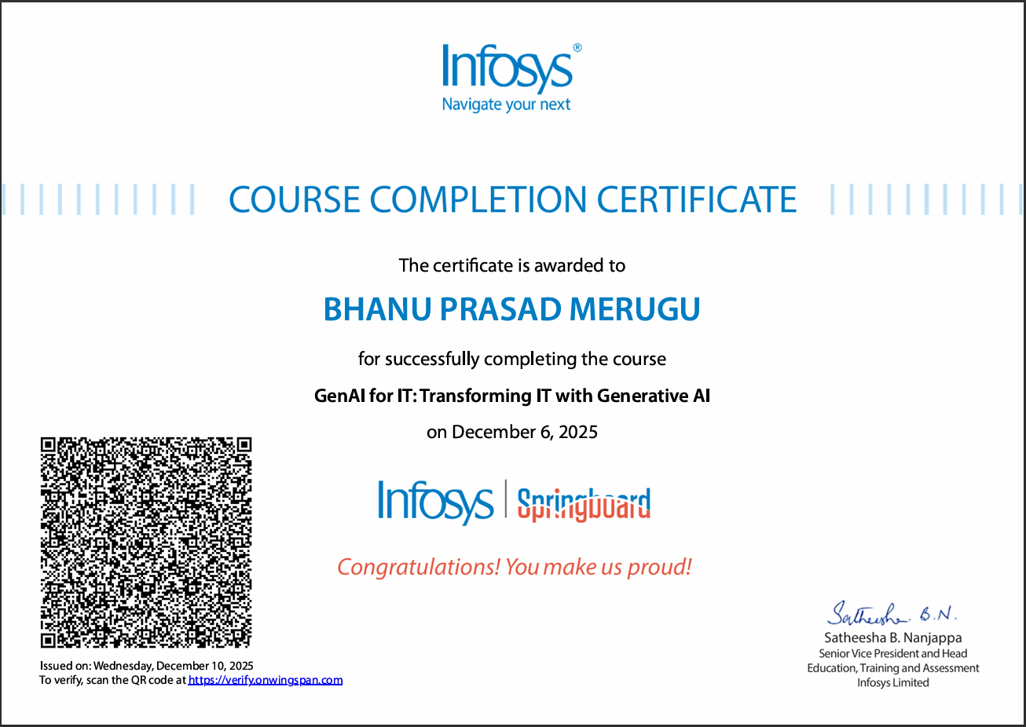

**Certification#6**

Title: Github Copilot with Python: Creating Text Games

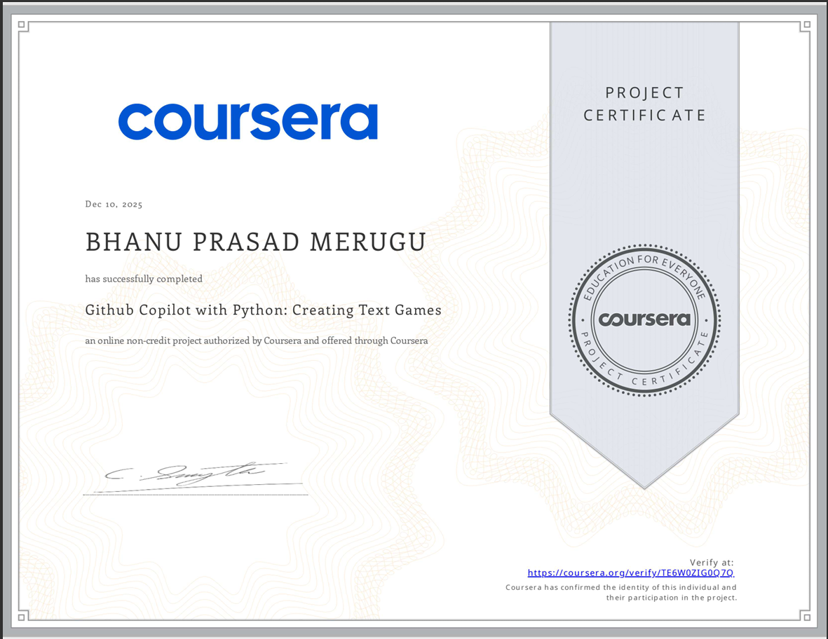

**Certification#7**

Title: Software Development with ChatGPT: Generating Code with AI

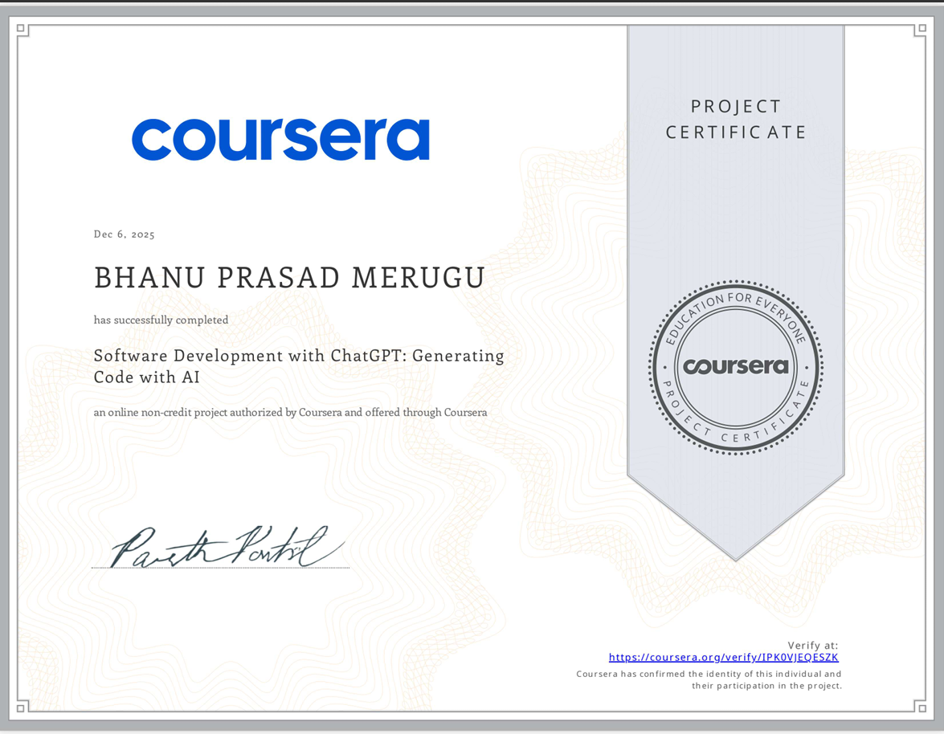

**Certification#8**

Title: Gen AI for developers: Web development with Python & Copilot

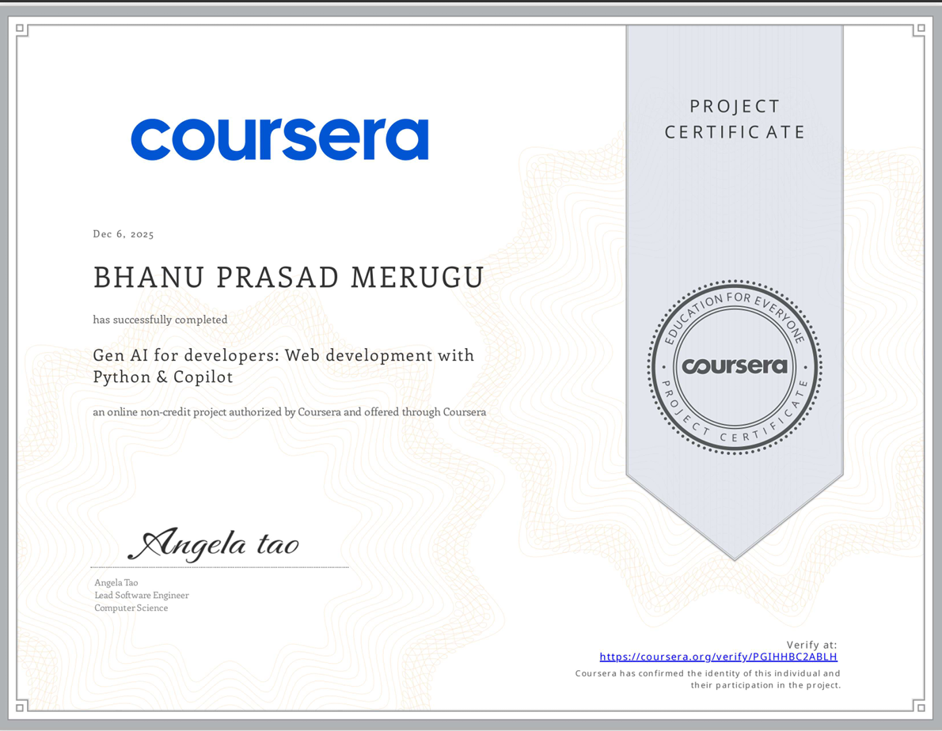

**Certification#9**

Title: Using JavaScript with AI: Enhancing Development Workflows

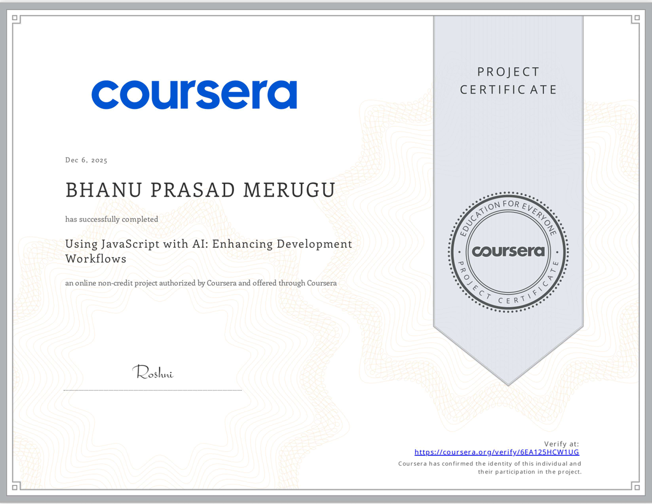

**Certification#10**

Title: Gen AI for Software Development: Code Generation for Python

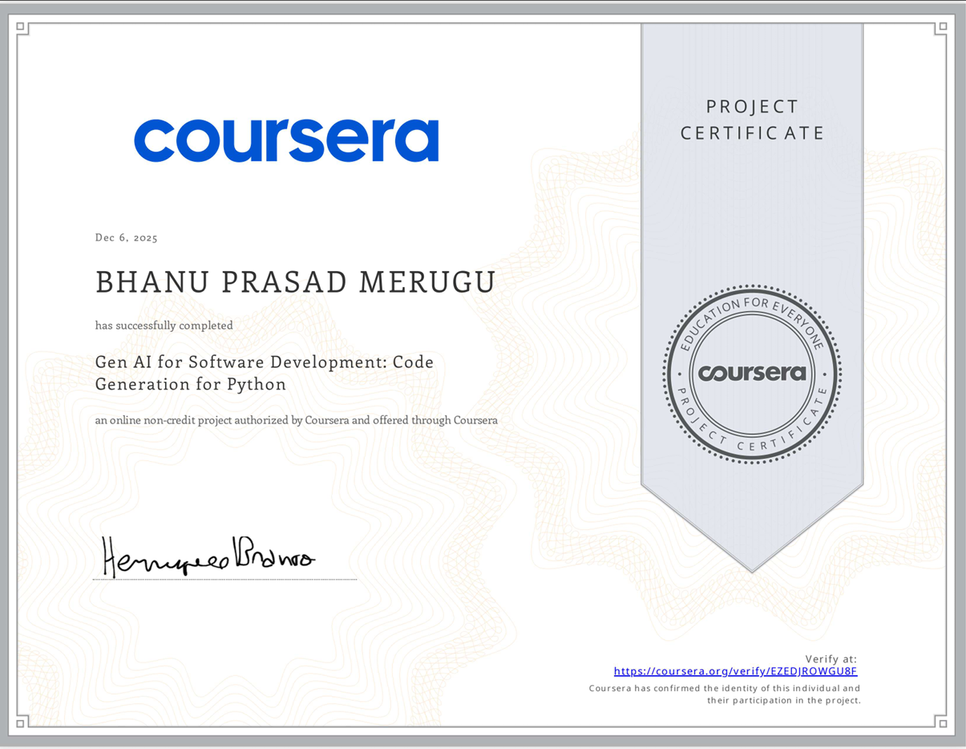

**Certification#11**

Title: Master Generative AI & Generative AI tools (ChatGPT & more)

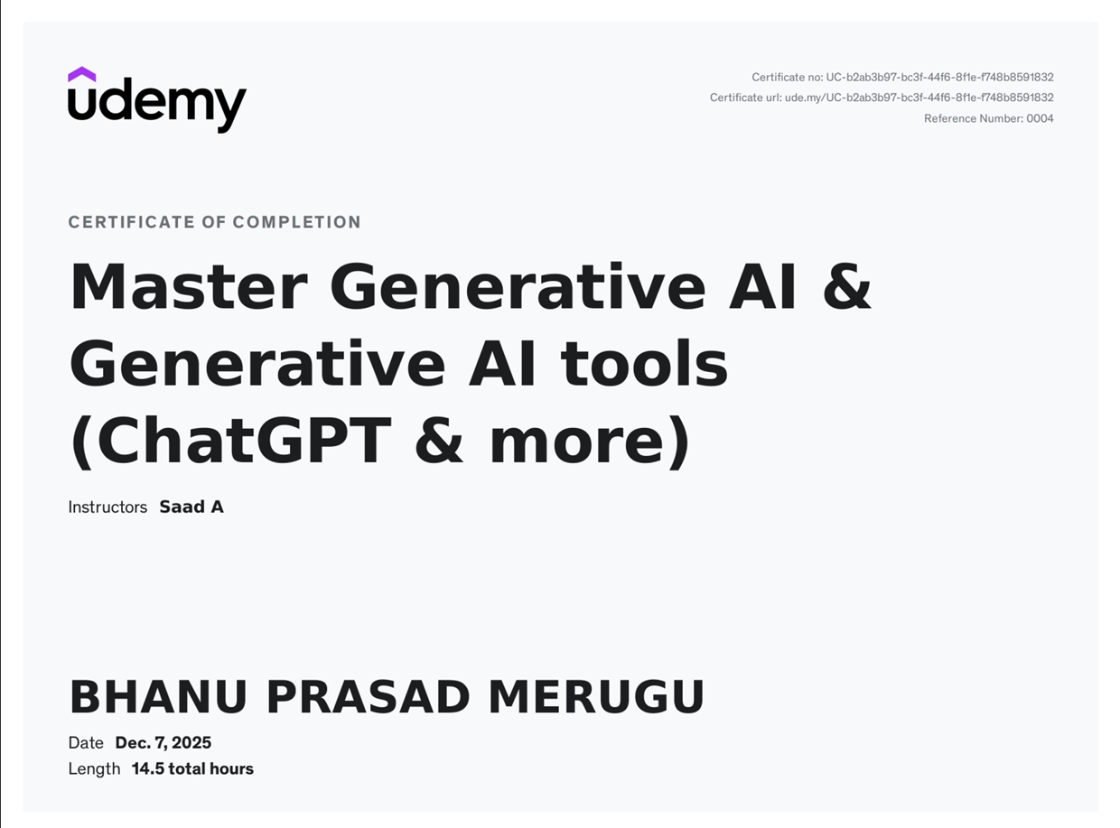

**Certification#12**

Title: Python Development with ChatGPT: Fullstack App Development

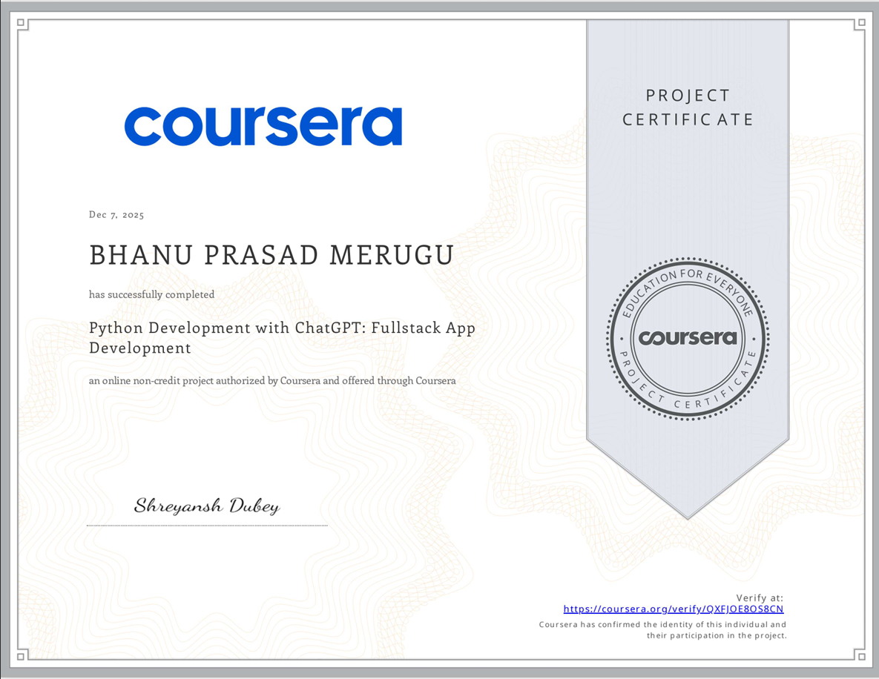

**Certification#13**

Title: PHP Development with ChatGPT: Practical Web Development

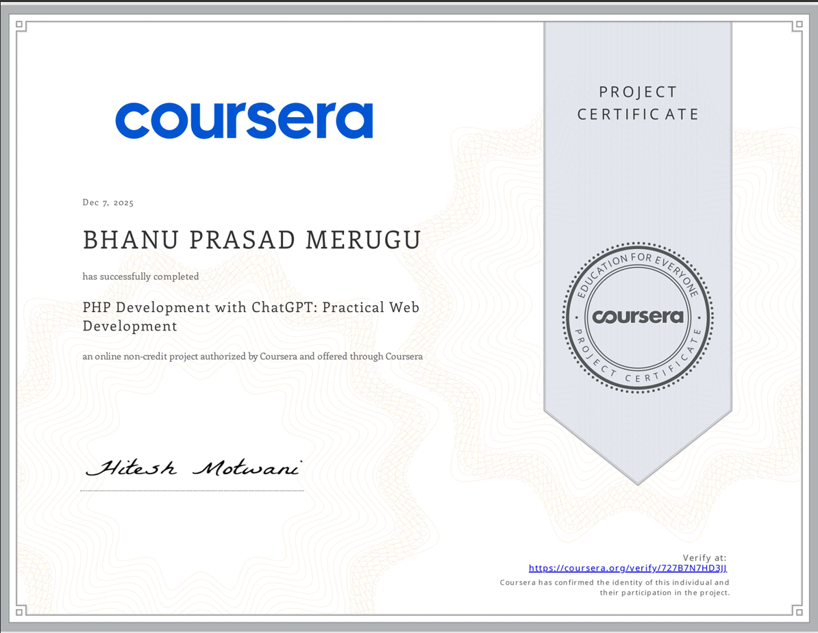

**Certification#14**

Title: AI-Powered Development with Codepal: Write & Test To-Do App

